Project Goal and Dataset Description
The objective of this project is to classify news articles into five distinct categories. The dataset used is the "BBC News"collection, which contains 2,225 text documents categorized into: Business, Entertainment, Politics, Sport, and Tech. The primary challenge in Natural Language Processing (NLP) is converting free text into a mathematical structure that a computer can process while preserving the semantic meaning of the words. In this project, we utilized the TF-IDF (Term Frequency-Inverse Document Frequency) representation, which ranks words based on their relative importance within a document compared to the entire corpus.

1. Establishing Baselines
Before constructing complex models in PyTorch, it is essential to define simple "reference points" (Baselines). these allow us to determine if a deep model is truly learning complex patterns or merely making statistical guesses.

A. Simple Baseline: Majority Class
This is the most basic model, relying solely on class distribution. It does not analyze the article's content but always predicts the most frequent category in the dataset (e.g., "Sport"). This model sets the minimum threshold that any deep learning model must surpass to prove its value.
- Results:
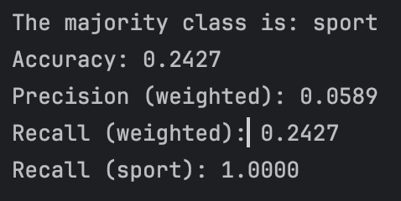

B. TF-IDF Dictionary-Based Baseline
Unlike a manually written dictionary, this second baseline is more sophisticated and based on a statistical analysis of the dataset itself.
- Dictionary Construction Process:
  - TF-IDF Calculation: We ran the TF-IDF algorithm on all articles in the dataset to identify words with high "discriminative power."
  - Keyword Extraction: For each of the 5 categories, we calculated the average TF-IDF scores for all words within that category.
  - Top 20 Selection: For each category, we selected the 20 words with the highest scores. These words form the "digital signature" of the category (e.g., in the "Tech" category, the dictionary includes terms like "broadband" or "operating system").
- Classification Process: When the model receives a new article, it checks the text against the five dictionaries. The article is classified into the category whose dictionary achieved the highest number of matches ("points").
- Significance: This model represents a simple "search engine" approach. It demonstrates the accuracy achievable through keyword recognition alone, without neural networks or weight optimization.
- Results:
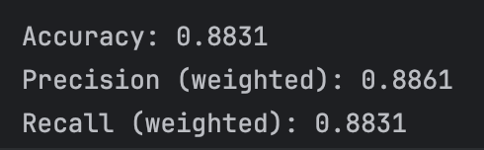

2. Softmax Regression Model
After determining the baselines, we developed a learning linear model based on Softmax Regression, trained using a Cross-Entropy Loss function.
A. Feature Tuning: Max Features Analysis:

A critical parameter in text representation is the number of features (words) chosen

Phase 1 - 500 Features: Using a limited vocabulary of the top 500 words, the model showed good convergence, but the Test Loss plateaued at a relatively high value (~0.2).

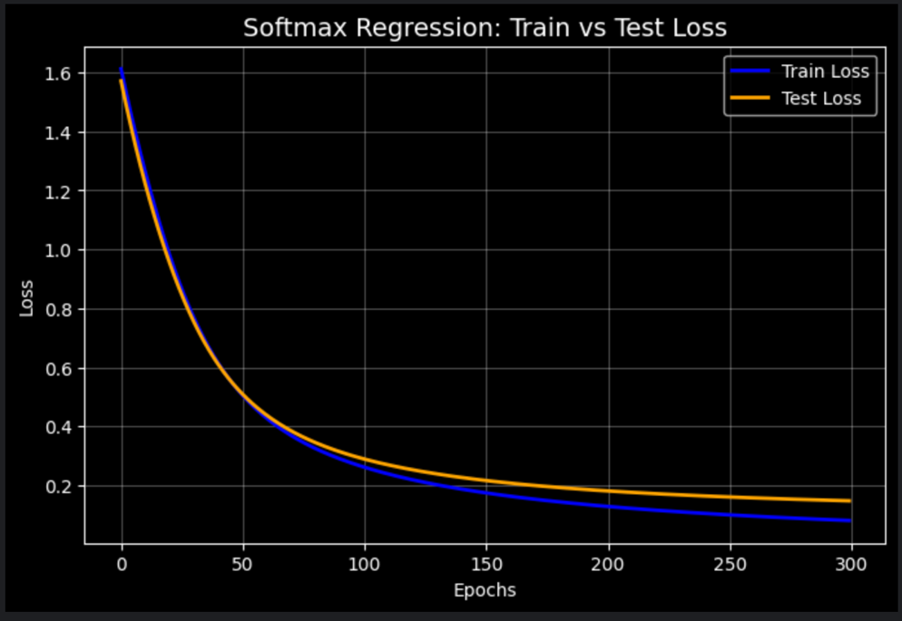
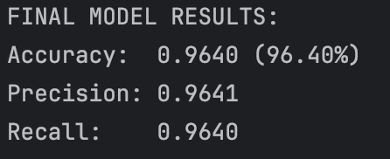
Analysis: This limitation caused partial Underfitting, as the model lacked sufficient information to distinguish between subtle nuances in similar categories.

Phase 2 - 2,000 Features: Increasing the vocabulary to 2,000 words significantly improved results. The Test Loss dropped much lower (~0.1).
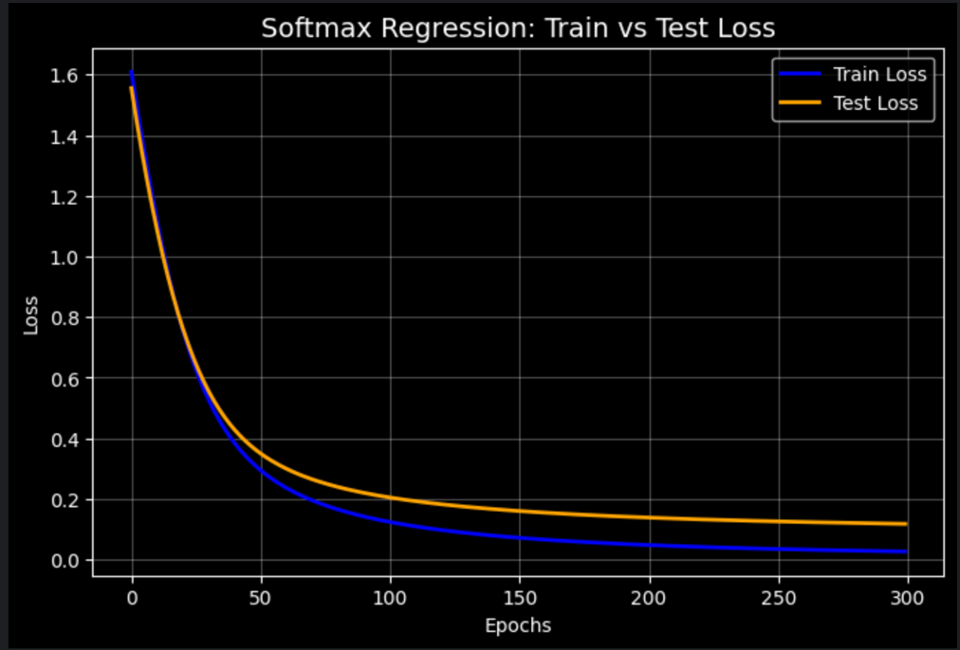

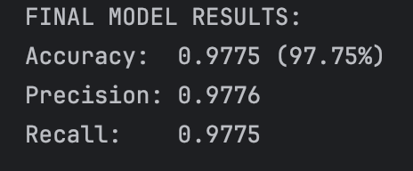

Conclusion: The additional features allowed the model to identify crucial keywords, leading to a direct improvement in final Accuracy while maintaining a small gap between training and testing (stable learning).
Comparison of Results (500 vs. 2000 features):

Features | Accuracy | Precision | Recall
500 | 0.9640 | 0.9641 | 0.9640
2000 | 0.9775 | 0.9776 | 0.9775

B. Learning Rate (LR) Analysis
We examined how changing the LR affects the learning process, comparing LR=0.01 and LR=0.001.
- Slow Learning (LR=0.001): The Loss decreased linearly but remained high (~0.6) after 300 epochs. The model was taking "steps" that were too small, leading to temporary Underfitting.
- Optimal Learning (LR=0.01): The Loss plummeted within the first 50 epochs and stabilized at a very low value (~0.1). This proved to be the ideal rate for efficiency and accuracy.
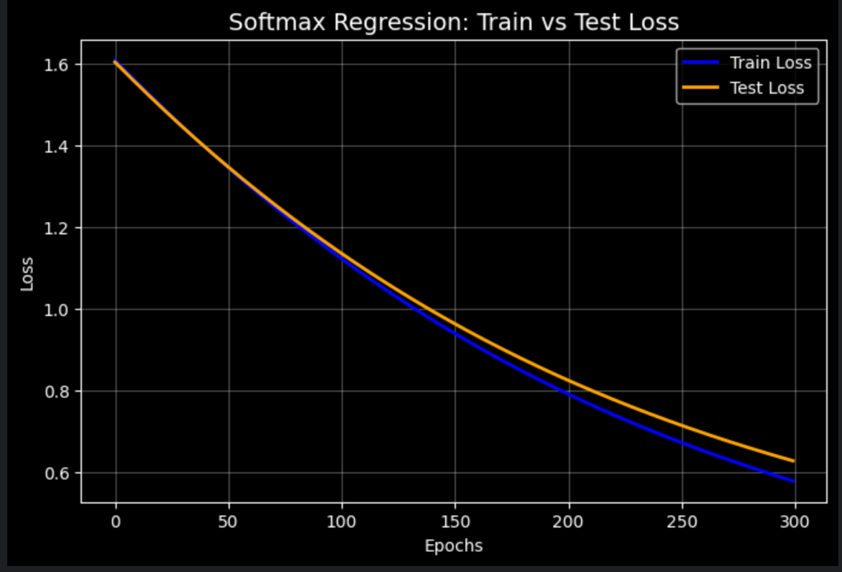
LR=0.001

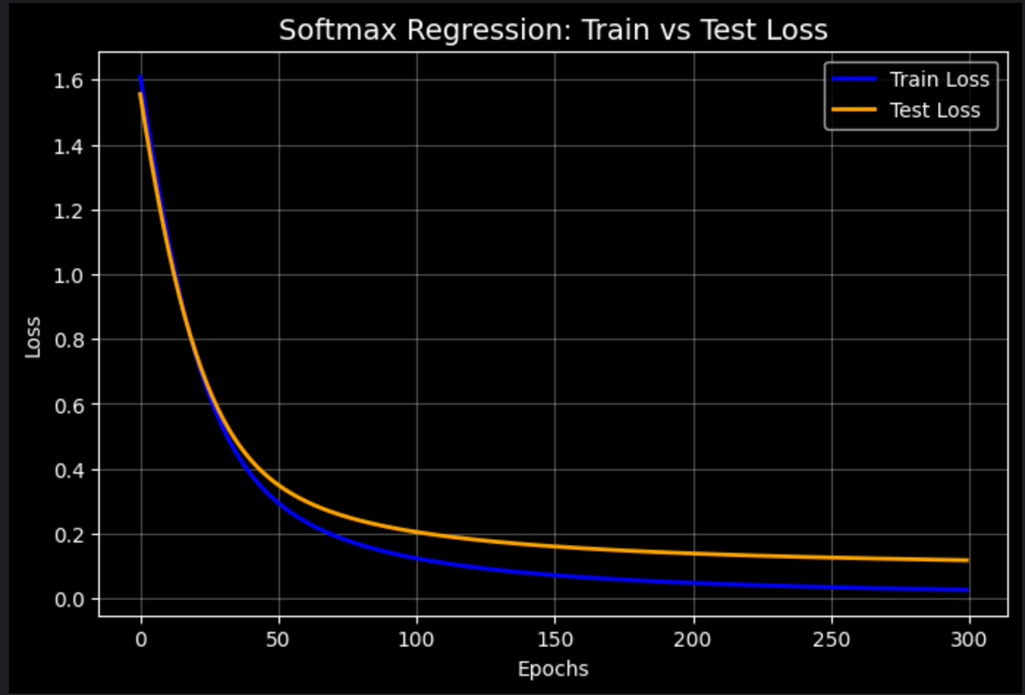

LR=0.01

Comparison of Results (LR=0.01 vs LR=0.001):

Learning rate | Accuracy | Precision | Recall
0.001 | 0.9663 | 0.9672 | 0.9663
0.01 | 0.9775 | 0.9776 | 0.9775

3. Deep Multi-Layer Perceptron
To improve classification further, we moved to a Deep MLP architecture with hidden layers, allowing the model to "understand" deeper correlations between TF-IDF features.

A. Two Hidden Layers without Regularization
- Observation: The model reached very high training accuracy rapidly but exhibited volatility in the test set.
- Diagnosis: The model showed weak signs of Overfitting. Without constraints, the network began "memorizing" the training data rather than learning general patterns.
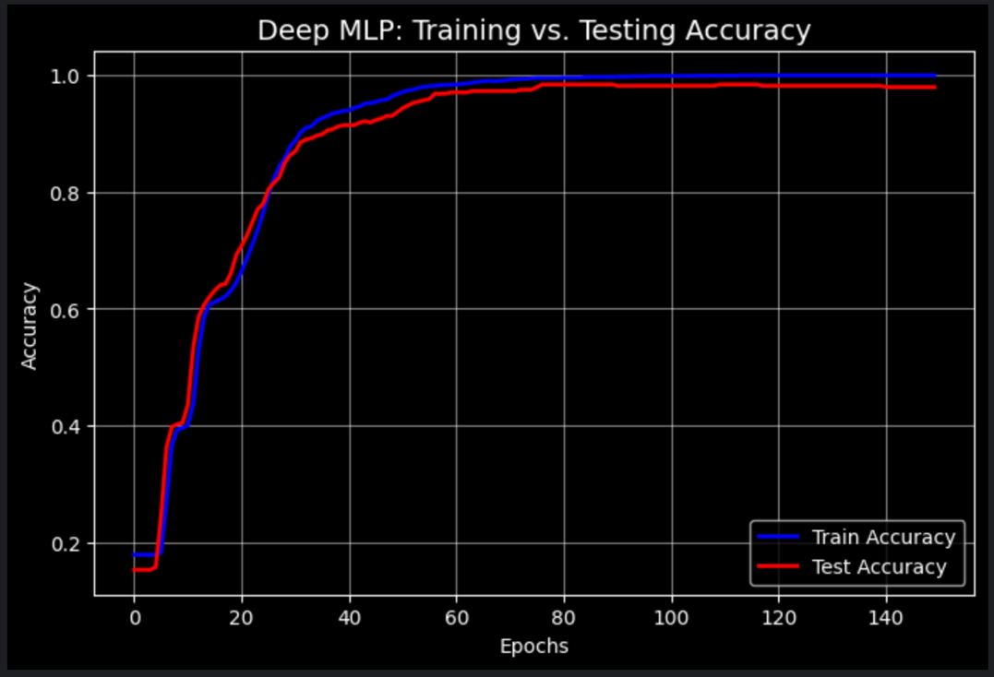

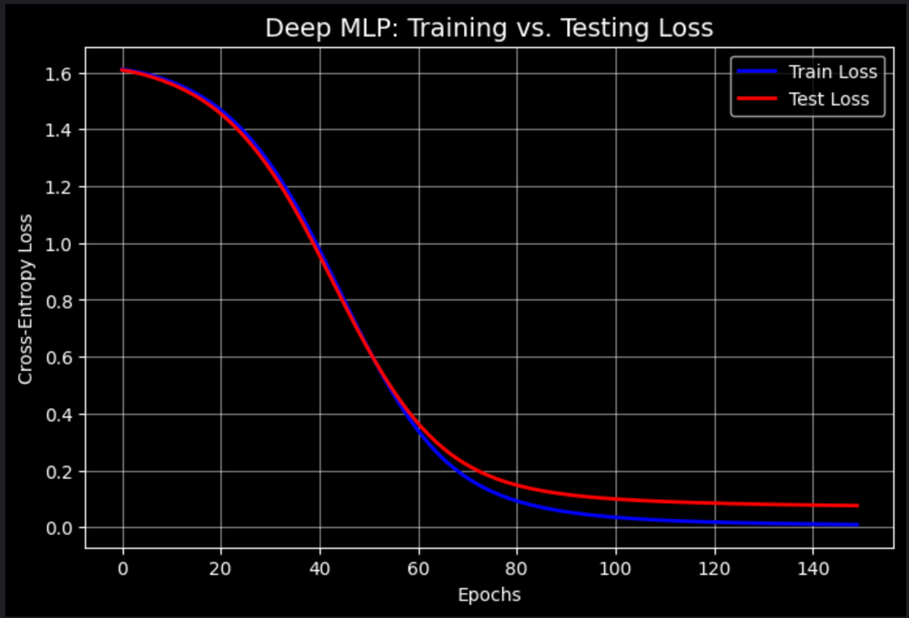

B.Regularization: Adding Dropout (0.3)
To mitigate overfitting, we added Dropout layers (p=0.3) after each hidden layer.
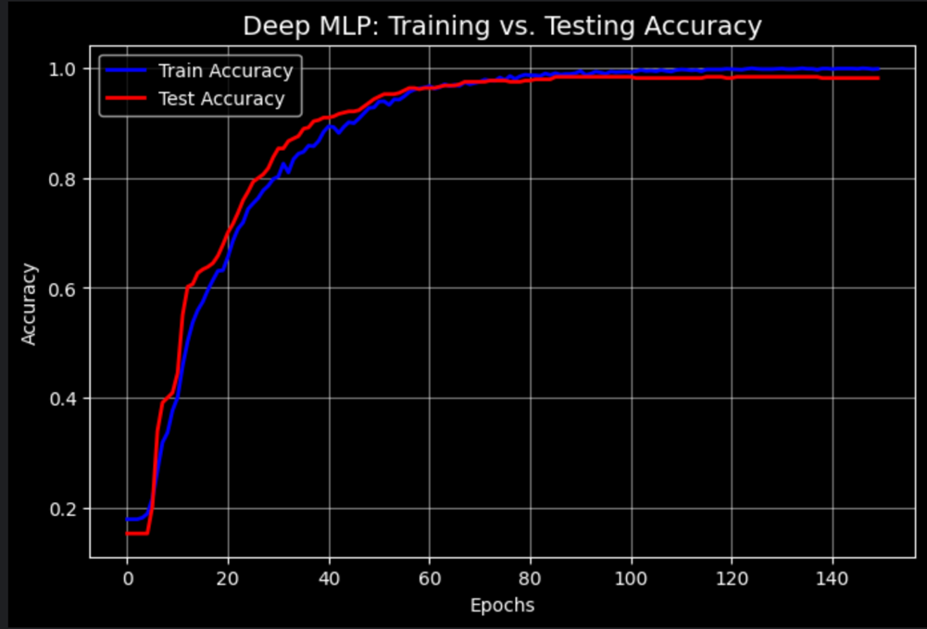

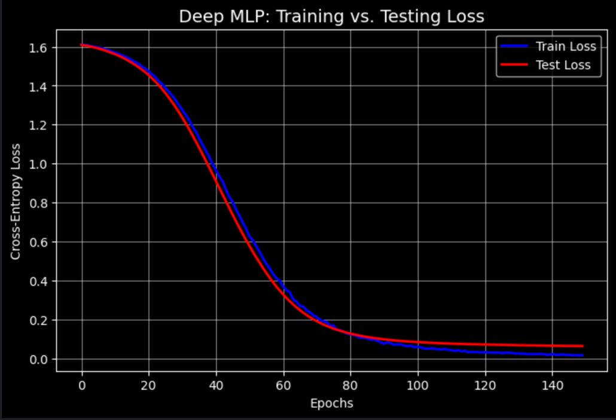

- Impact: Learning became more gradual and smoother. The gap between training and test accuracy minimized, indicating robust Generalization.
- Convergence Analysis:
  - Without Dropout: Convergence occurred early (around Epoch 60), but was unstable.
  - With Dropout 0.3: Convergence was delayed (around Epoch 80), but the result was much more resilient. The delay proves the regularization effect, forcing the network to find generalized paths rather than shortcuts.
We can observe here more clearly the gap between the train error and the test error towards the last epochs before and after regularization:
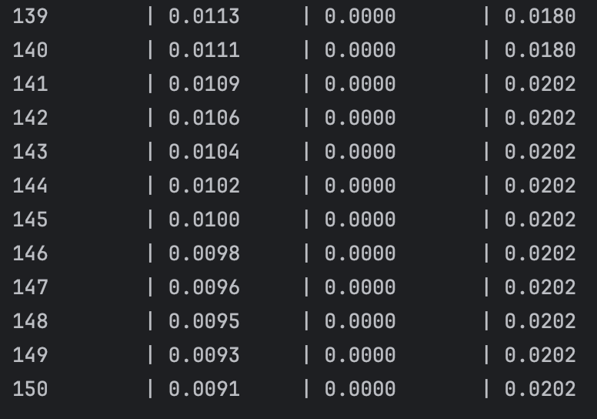
without dropout:
Epoch Loss Train Error Test Error

With dropout:
Epoch Loss Train Error Test Error
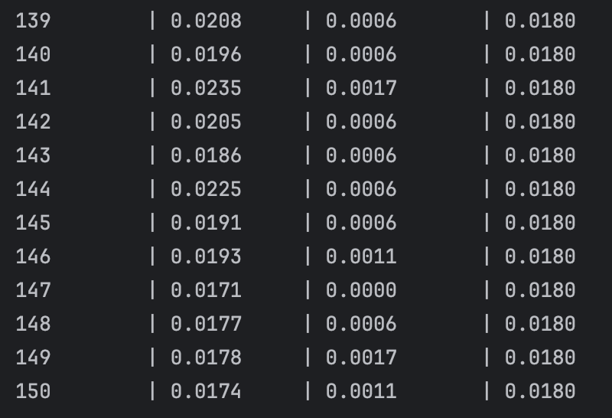

C. adding 4 Hidden Layers
We tested whether doubling the hidden layers (from 2 to 4) would yield further gains.
- Results: Adding layers led to negative performance. While Training Loss continued to drop toward zero, the Test Loss began to rise after epoch 40.
- Conclusion (Over-Complexity): The 4-layer model became too complex for the problem. For 2,000 TF-IDF features, two layers provide sufficient "computational power." The deeper architecture only introduced mathematical "noise" and severe overfitting.

Comparison of Results:

Num of hidden layers | Dropout(0.3) | Accuracy | Precision | Recall
2 | with | 0.9820 | 0.9821 | 0.9820
4 | with | 0.9640 | 0.9641 | 0.9640
2 | without | 0.9798 | 0.9799 | 0.9798
4 | without | 0.9596 | 0.9598 | 0.9596

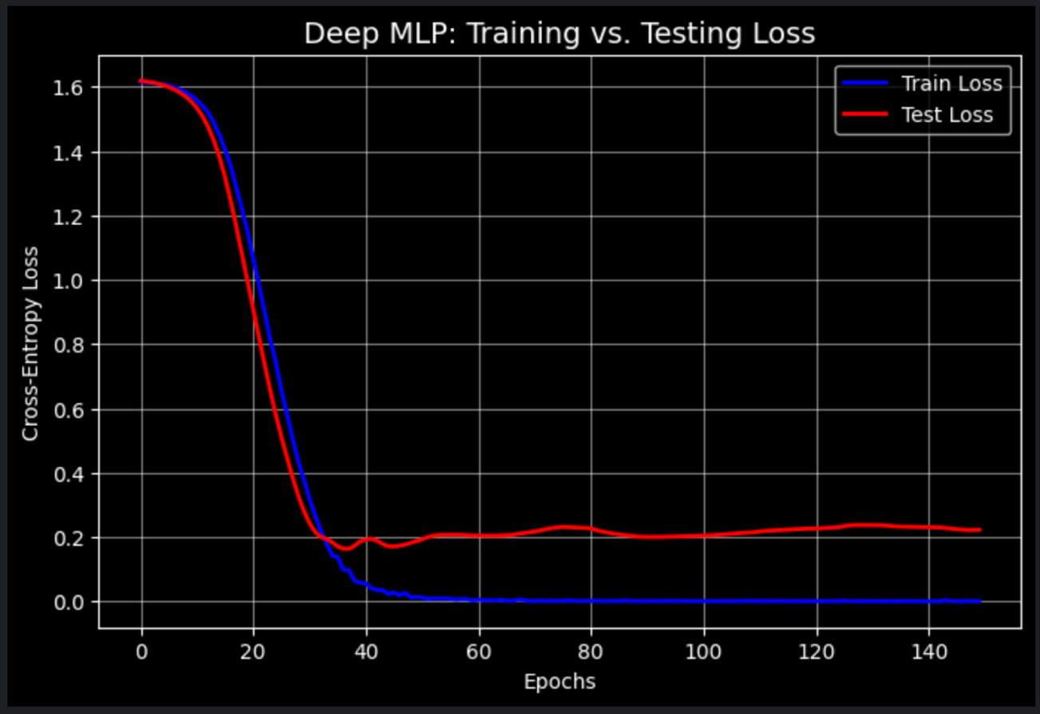
Conclusion: in this model 2 layers are always better than 4 layers, and better with dropout.
4. Final Comparaision:
Model | Accuracy | Precision | Recall
Simple Baseline (Majority) | 24.27% | 0.0589 | 0.2427
Rule-Based (Dictionary) | 88.3% | 0.8862 | 0.8831
Softmax Regression | 97.75% | 0.9776 | 0.9775
Deep MLP (Best Model) | 98.20% | 0.9821 | 0.9820

The Leap from Baseline: The jump from 22% to 98.2% proves the model is genuinely learning content rather than guessing.
Softmax vs. MLP: The MLP provided a 0.45% improvement over Softmax. While seemingly small, it is significant at this high-accuracy tier, indicating that hidden layers successfully resolved "edge cases" that the linear model missed.

